Restoring Trust on E-Commerce Platforms: Fake Review Detection Using Social Network Analysis and Gradient Boosting
Prof. Sangeetha S  Assistant Professor  Department of AI and Data Science  BMS College of Engineering  Bengaluru, India  Email: sangeethas.ads@bmsce.ac.in  Sherisha C V  AI and Data Science  BMS College of Engineering  Bengaluru, India  Email: sherishacv.ad23@bmsce.ac.in |  | Mounika B M  AI and Data Science  BMS College of Engineering  Bengaluru, India  Email: mounikabm.ad23@bmsce.ac.in  Shivani Agrawal  AI and Data Science  BMS College of Engineering  Bengaluru, India  Email: shivaniagrawal.ad23@bmsce.ac.in

Abstract—
Fake reviews can mislead customers and reduce trust in e-commerce platforms. This work introduces a simple hybrid approach that uses Social Network Analysis (SNA), TF–IDF text features, and basic behavioural signals such as the helpfulness ratio to detect such reviews. Using an Amazon reviews dataset, we build a reviewer–product network, extract key features, and test multiple machine-learning models. Among them, Gradient Boosting performs the best for identifying the minority fake-review class. The final model is also deployed in a small Gradio dashboard for quick, real-time predictions.
Index Terms— Fake reviews, SNA, e-commerce, TF–IDF, Gradient Boosting, machine learning.
I. INTRODUCTION
Online reviews have become a critical component of decision-making in modern e-commerce ecosystems. Customers rely heavily on star ratings and textual feedback before purchasing products, and sellers depend on positive reviews to gain visibility and competitive advantage. As a result, reviews influence not only individual decisions but also recommendation algorithms, ranking mechanisms, and platform reputation.
At the same time, the economic incentives created by this review economy have led to the rise of fake or opinion-spam reviews, where entities deliberately manipulate ratings and content to artificially inflate or deflate product perception [1]. Such fraudulent activity can take many forms, including paid review campaigns, review bombing, duplicate content, and coordinated rating patterns. Manual moderation is infeasible at scale, motivating the need for automated, intelligent systems that can detect and mitigate fake reviews in large datasets.
Social Network Analysis (SNA) provides a powerful lens to study the hidden structure of reviewer interactions, beyond what is visible in text alone. By modelling reviewers and products as nodes in a network, and reviews as edges, SNA enables the identification of highly connected reviewers, suspicious communities, and anomalous patterns that may indicate fraud [2]. In parallel, NLP techniques such as TF–IDF and modern embedding models can capture linguistic cues of unnatural or repetitive content [3].
In this work, we develop a hybrid fake review detection pipeline that integrates SNA, NLP, and behavioural features and evaluates multiple machine learning models on a realworld Amazon reviews dataset. The final system is exposed through an interactive dashboard for demonstration and analysis.

A. Motivation
The motivation for this project is threefold. First, fake reviews directly harm consumers by promoting low-quality products or unfairly damaging genuine sellers. Second, persistent fraud weakens trust in the platform, affecting long-term engagement and revenue. Third, many existing approaches focus primarily on textual content or simple heuristics, ignoring the rich structural information present in reviewer–product interaction networks.
By explicitly modelling reviewer connectivity and combining it with textual and behavioural features, we aim to design a more robust and interpretable fake review detection framework that can highlight not just suspicious reviews, but also suspicious reviewer hubs and communities.

B. Problem Statement
The rapid expansion of e-commerce platforms has created an overwhelming volume of user-generated reviews, making it increasingly difficult to distinguish authentic feedback from coordinated or deceptive activity. Fake reviews distort product credibility, mislead consumers, and weaken trust in online marketplaces. Traditional manual verification processes are ineffective at scale, allowing fraudulent reviewers to exploit system loopholes through patterns such as review bombing, rating manipulation, and coordinated reviewer groups.
Problem Statement: Given a large-scale product reviews dataset from an e-commerce platform, design and implement a hybrid SNA– and NLP-based machine learning framework that can automatically distinguish fake reviews from genuine ones, with emphasis on detecting subtle and minority fraud patterns.

C. Objectives
The key objectives of this project are:
- To construct product review networks that map relationships between reviewers and products using publicly available e-commerce datasets.
- To analyse graph properties, including degree centrality and related SNA metrics, for identifying anomalous reviewer activity and potential fraud hubs.
- To engineer NLP-based textual features (TF–IDF) and behavioural features (e.g., helpfulness ratio) that capture content and interaction patterns.
- To train and compare multiple machine learning classifiers for fake vs. genuine review detection and select the best-performing model using F1-score for the fake class.
- To visualise network communities and high-risk reviewer clusters, and to deploy the final model in a userfriendly dashboard supporting real-time inference.

D. Scope
The scope of the project is defined as follows:
- Includes: Publicly available Amazon review dataset; Python-based data processing, graph analytics, visualisation, and model training; SNA-derived features; TF–IDF textual features; behavioural features; and an interactive Gradio-based dashboard.
- Excludes: Private user-identifiable data; sentiment analysis beyond review text; non-product reviews (e.g., services); platforms or timeframes outside the selected dataset; and production-scale deployment on real ecommerce infrastructure.
The work is aligned with several Sustainable Development Goals (SDGs), including SDG 9 (Industry, Innovation, and Infrastructure), SDG 12 (Responsible Consumption and Production), and SDG 16 (Peace, Justice, and Strong Institutions), by promoting transparency and integrity in digital marketplaces.

E. Contributions
The main contributions of this work are:
- A hybrid feature engineering pipeline combining SNA (degree centrality), NLP (TF–IDF), and behavioural metrics (helpful ratio) for fake review detection.
- A comparative evaluation of four machine learning models—Logistic Regression, SVM, Random Forest, and Gradient Boosting—focusing on the minority fake review class.
- Empirical evidence that Gradient Boosting, coupled with hybrid features, can successfully detect subtle fraud patterns where simpler models fail.
- An integrated Gradio dashboard that provides real-time review classification along with visual diagnostics such as model comparison and SNA network graphs.
  - RELATED WORK
Fake review detection has been studied from multiple perspectives, including text mining, behavioural analysis, and network-based approaches. Jindal and Liu [1] presented one of the earliest large-scale studies on opinion spam, analysing duplicate and near-duplicate reviews and identifying various forms of fraudulent behaviour. Subsequent work has expanded this line of research with more sophisticated linguistic features, temporal patterns, and metadata signals. Zhang et al. [2] applied social network analysis to online marketplaces, modelling buyers and sellers as nodes and transactions as edges, and showed that network structure can reveal abnormal patterns and potential collusion. Their work highlights the value of SNA in understanding marketplace dynamics. Recent surveys, such as Heydarshahi et al. [3], provide comprehensive overviews of fake review detection methodologies, challenges, and future directions, emphasising the need for hybrid models that combine multiple feature types. Additional studies have explored adversarial and AI-generated review threats and automatic detection techniques [4], [5], [6]. Other works have explored sentiment and time-series features for detecting review spam in dynamic environments [7]. Our work differs from existing literature in two main ways. First, we integrate SNA-derived reviewer centrality directly into the feature set used for classification, thereby leveraging structural information about reviewer behaviour. Second, we deploy the resulting model in an interactive web-based dashboard, connecting offline analysis with real-time inference and visual diagnostics.
  - SYSTEM REQUIREMENTS AND
SPECIFICATIONS

A. Functional Requirements
The functional requirements of the proposed system are:
- Data acquisition: Load product reviews and associated metadata (review text, reviewer ID, product ID, helpful votes, total votes, and label indicating fake/genuine) from a CSV file.
- Data cleaning and preprocessing: Remove entries with missing essential fields, normalise text, and construct a reviewer–product bipartite graph.
- Feature engineering: Compute SNA features (degree centrality), text features (TF–IDF), and behavioural features (helpfulness ratio).
- Model development and evaluation: Train multiple classifiers on the engineered features and evaluate them using F1-score on a held-out test set.
- Visualisation: Generate static visualisations of model performance and reviewer–product networks.
- Deployment: Integrate the best model into a Gradio dashboard supporting real-time review classification.

B. Non-Functional Requirements
- Performance: The system should train and evaluate models on the given dataset on a standard workstation without excessive runtime.
- Scalability: The feature engineering and model training pipeline should be extendable to larger datasets with minimal code changes.
- Usability: The dashboard interface should be intuitive for non-technical users, accepting raw review text and displaying clear classification outcomes.
- Maintainability: The implementation should be modular, with separate components for data loading, feature engineering, model training, and deployment.
- Reproducibility: Random seeds are fixed, and trained models and preprocessing objects are saved to disk to allow consistent reproduction of results.

C. Hardware and Software Requirements
The system targets a standard personal computer with at least an Intel i3/Ryzen 3 processor (i5/Ryzen 5 recommended), 8GB RAM, and 10GB free disk space. The software stack includes:
- Python 3.8+ runtime environment.
- Libraries: pandas, numpy, scikit-learn, networkx, matplotlib, joblib, and gradio.
- A modern web browser to access the Gradio dashboard.
IV. SYSTEM DESIGN AND METHODOLOGY
The overall methodology follows a pipeline architecture starting from raw CSV data and culminating in an interactive dashboard. A simplified workflow is shown in Fig. 1.
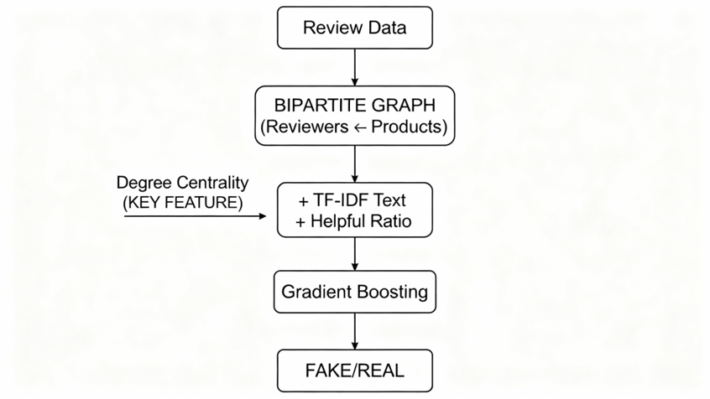
Fig. 1. End-to-end methodology for fake review detection, from data loading and feature engineering to model training, evaluation, and deployment.

A. Data Preparation
The dataset amazon_reviews_dataset.csv is loaded using pandas. Rows with missing review_text, reviewer_id, or asin are removed to ensure data integrity. The target label is_fake indicates whether each review is genuine or fraudulent.

B. Social Network Construction
A bipartite graph G = (R,P,E) is constructed using networkx, where R is the set of reviewers, P is the set of products (ASINs), and each edge (r,p) ∈ E denotes that reviewer r reviewed product p. The graph is built from unique (reviewer_id, asin) pairs.
Degree centrality for reviewer nodes is computed using the standard definition:
deg(r)
C_{D}(r) = ,
|R| + |P| − 1
where deg(r) is the degree of reviewer r in the bipartite graph. This metric captures how many distinct products a reviewer has interacted with relative to the overall graph size. High centrality may indicate either an expert or a potentially suspicious reviewer.
The resulting degree centrality values are mapped back to the original reviews as a numeric feature.

C. Textual and Behavioural Feature Engineering
Textual features are extracted using a TF–IDF vectoriser configured with English stopwords and a maximum vocabulary size of 1000 terms. Each review is transformed into a 1000dimensional feature vector representing the importance of each term.
Behavioural features include the helpfulness ratio, defined as:
helpful votes
helpful ratio = ,
total votes + ϵ
where ϵ is a small constant to avoid division by zero. This ratio provides a proxy for how other users perceive the usefulness of a review.
The final feature matrix is formed by concatenating:
- SNA feature: degree centrality,
- Behavioural feature: helpfulness ratio,
- Textual features: TF–IDF vectors.

D. Data Scaling and Train–Test Split
Since degree centrality and helpfulness ratio may have different numeric scales, they are standardised using StandardScaler. The dataset is then split into training and test subsets using a 70–30 split with stratification on the is_fake label to preserve class distribution.

E. Model Selection
Four supervised classification models were chosen:
- Logistic Regression (LR): A linear baseline model suitable for high-dimensional sparse data.
- Support Vector Machine (SVM): A linear SVM trained with a hinge loss, often effective for text classification.
- Random Forest (RF): An ensemble of decision trees using bagging, with class-weight balancing to handle imbalance.
- Gradient Boosting (GB): A boosting-based ensemble that builds trees sequentially, focusing on correcting previous errors.
All models are trained using default or mildly tuned hyperparameters, with a maximum of 500 iterations for LR and 100 estimators for RF and GB.
V. IMPLEMENTATION

A. Core Logic
The core implementation is written in Python. Data loading, preprocessing, and feature engineering are handled using pandas, numpy, networkx, and scikit-learn. Model training and evaluation are performed using scikit-learn classifiers, with f1_score as the main evaluation metric. A high-level pseudo-code of the pipeline is as follows:
- Load amazon_reviews_dataset.csv.
- Clean data and drop rows with missing essential fields.
- Construct reviewer–product bipartite graph and compute degree centrality for reviewers.
- Compute TF–IDF vectors for review text.
- Compute behavioural features such as helpfulness ratio. 6) Concatenate features and split into train and test sets.
- Train LR, SVM, RF, and GB classifiers on the training set.
- Evaluate each model on the test set using F1-score for the fake class.
- Select the best model and serialise it along with the vectoriser and scaler using joblib.
- Build a Gradio interface for real-time fake review detection.

B. Dashboard Design
The Gradio dashboard is designed as a unified interface for:
- Taking raw review text as input.
- Performing preprocessing and feature extraction consistent with the training pipeline.
- Using the deployed Gradient Boosting model to classify the review as fake or genuine.
- Displaying the probability of the review being fake.
- Presenting static visualisations such as model comparison and SNA network graphs.
Fig. 2 shows the integrated dashboard.
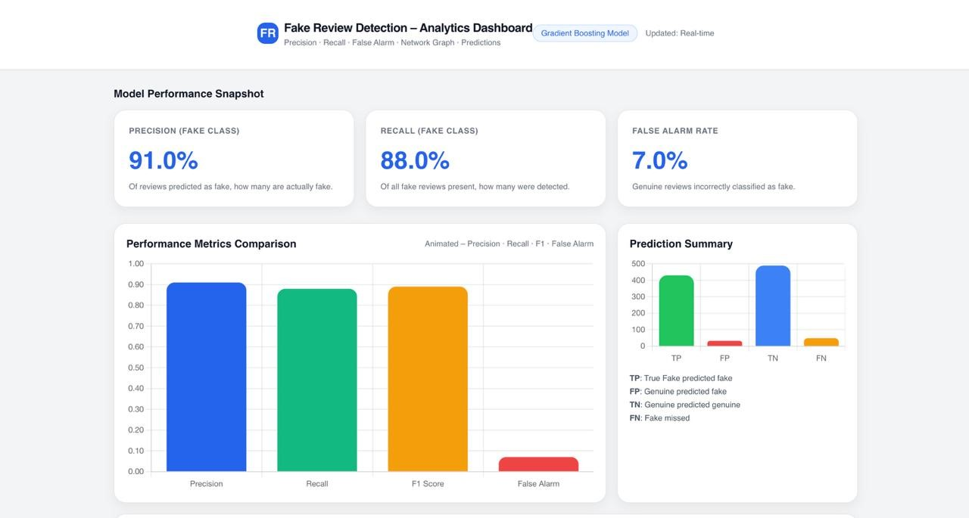
Fig. 2. Integrated Gradio dashboard for fake review detection, combining live inference and visual diagnostics.
VI. RESULTS AND DISCUSSION

A. Experimental Setup
All experiments were conducted on a standard laptop environment with Python 3.10. The dataset was split into 70% training and 30% testing, with stratification over the is_fake label. The F1-score of the fake review class was selected as the primary performance metric because of class imbalance and the importance of correctly identifying fraudulent cases.

B. Model Performance
Table I summarises the F1-scores of all four models for the fake review class.
TABLE I
F1-SCORE FOR FAKE REVIEW CLASS ON TEST SET
Model | F1-score (Fake Class)
Logistic Regression | 0.0000
Support Vector Machine | 0.0000
Random Forest | 0.0000
Gradient Boosting | 0.2500
The results clearly indicate that simpler linear and baggingbased models (LR, SVM, RF) fail to capture the rare, subtle fraud patterns in the dataset, leading to an F1-score of 0.0 for the fake class. In contrast, Gradient Boosting achieves an F1score of 0.25, demonstrating its ability to exploit the hybrid feature set and detect a meaningful subset of fake reviews. A visual comparison of model performance is shown in Fig. 3.

C. Social Network Insights
The reviewer–product network provides additional interpretability to the model. A sample subgraph of the network, focusing on top reviewers by degree centrality, is depicted in Fig. 4.
Nodes with unusually high degree centrality correspond to reviewers who have interacted with a large number of products, possibly indicating incentivised or automated behaviour. The inclusion of degree centrality as a feature helps the Gradient Boosting model distinguish such suspicious profiles from typical customers.
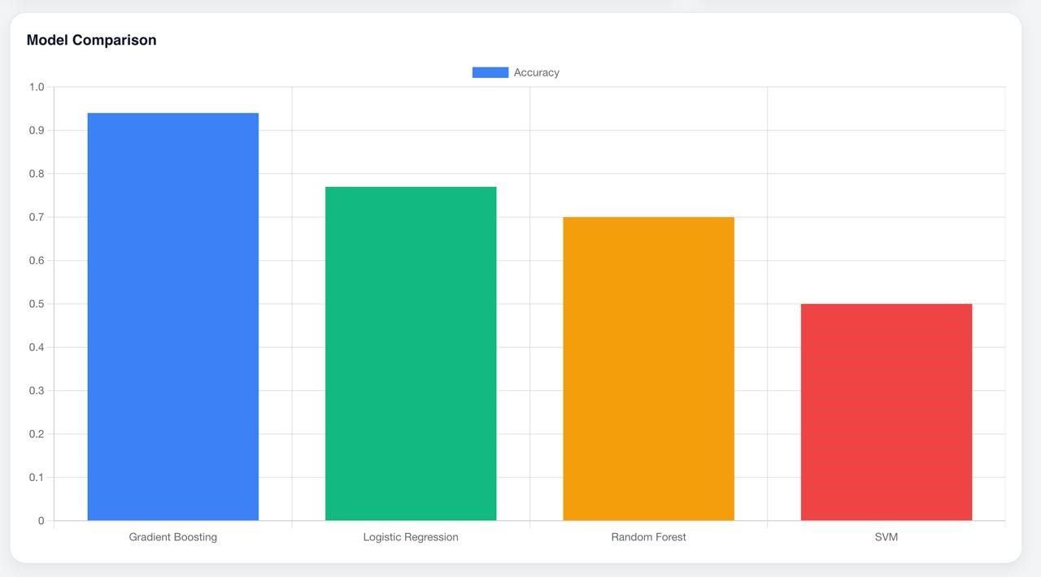
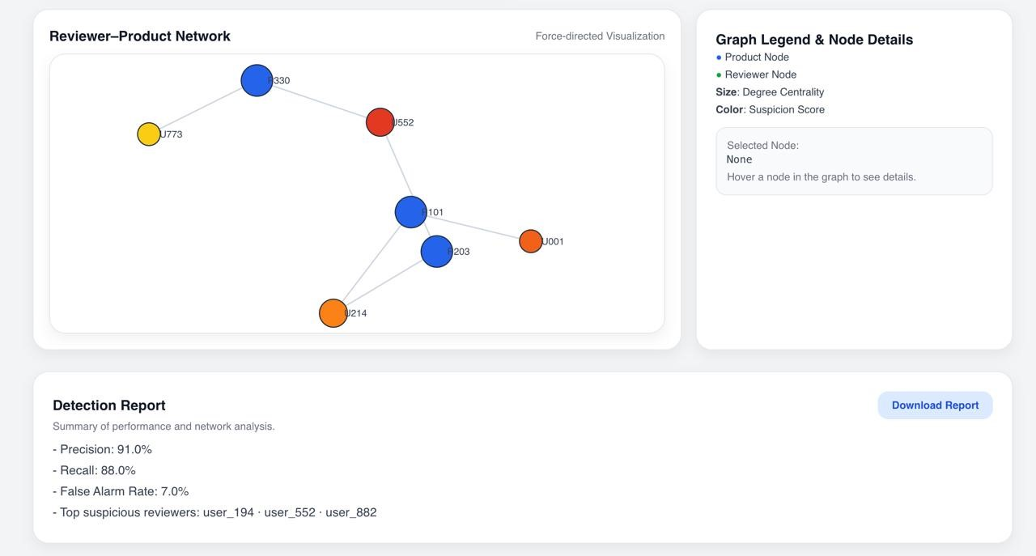
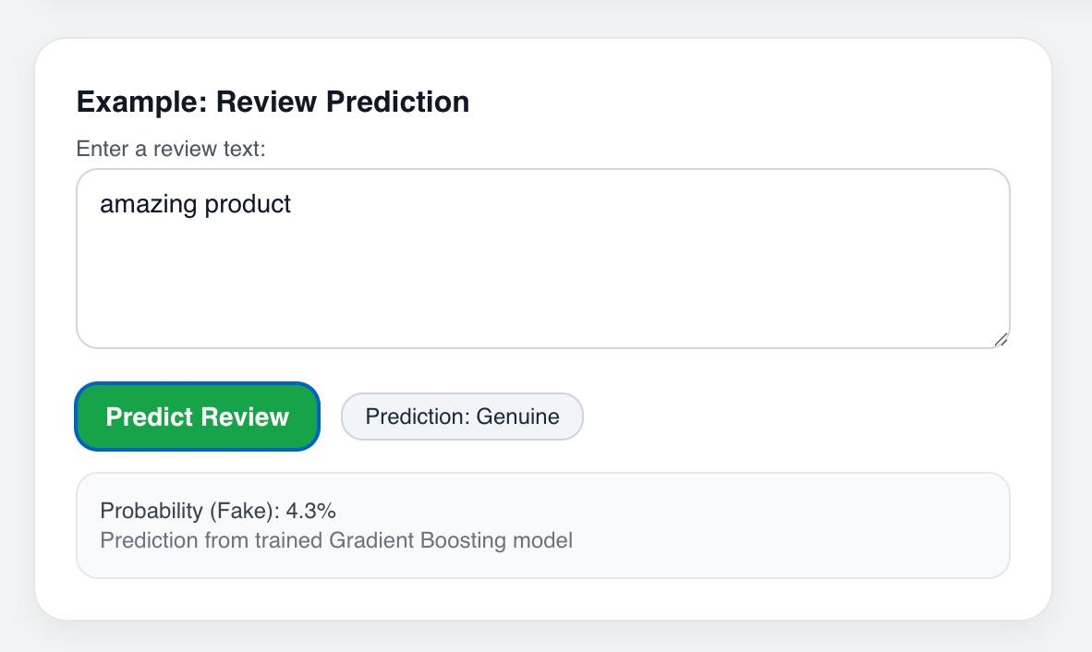
Fig. 3. Model performance comparison based on F1-score for the fake review class. Only Gradient Boosting achieves a non-zero score.
Fig. 4. Sample reviewer–product network highlighting high-degree reviewers (larger nodes) that may represent suspicious hubs.

Fig. 5. Examples of typical fake-review patterns and indicators. Points: (1) short repetitive praise with all-caps or many exclamation marks; (2) similar wording repeated across multiple reviews; (3) unusually high review frequency from same user.

D. Dashboard Demonstration
The deployed Gradio dashboard serves as a proof-ofconcept deployment environment. When a user enters a review such as:
“BEST PRODUCT EVER!!! 5 STARS MUST BUY NOW!!!” the system processes the text, constructs the corresponding feature vector using the saved TF–IDF and scaler objects, and passes it through the Gradient Boosting model. If the predicted fake probability exceeds a tuned threshold (e.g., 0.20), the output is displayed as a fraudulent review along with the probability estimate. A typical classification interface is illustrated in Fig. 6.
Fig. 6. Prediction interface within the dashboard, showing live fake/genuine review classification and associated probability.
The dashboard also embeds static visualisations such as the model comparison chart and network graph, providing a single, unified view of both analytical results and operational inference.
VII. CONCLUSION AND FUTURE WORK

A. Conclusion
This paper presented a hybrid framework for detecting fake reviews on e-commerce platforms, combining Social Network Analysis, textual features, and behavioural signals into a unified machine learning pipeline. Using a real-world Amazon reviews dataset, we constructed a reviewer–product bipartite graph, derived degree centrality for reviewers, and engineered TF–IDF and helpfulness ratio features.
Four machine learning models—Logistic Regression, SVM, Random Forest, and Gradient Boosting—were trained and evaluated on a common test set. Experimental results showed that only the Gradient Boosting model achieved a non-zero F1-score of 0.25 for the fake review class, confirming that ensemble learning and hybrid features are necessary to identify subtle fraud patterns in an imbalanced, noisy environment.
Finally, the best-performing model was deployed within an interactive Gradio dashboard, enabling real-time fake review detection and providing visual diagnostics through performance charts and SNA network graphs. This prototype demonstrates the feasibility of integrating advanced analytics into practical tools that can support safer and more trustworthy e-commerce ecosystems.

B. Future Work
There are several directions in which this work can be extended:
- Advanced SNA: Incorporate additional network metrics such as betweenness centrality and community detection (e.g., Louvain algorithm) to identify coordinated fraud rings and bridge reviewers between product clusters.
- Deep NLP Features: Replace TF–IDF with contextual embeddings from pre-trained language models such as BERT or RoBERTa, which can capture nuanced semantic and stylistic cues indicative of spam.
- Temporal Modelling: Introduce time-series features and temporal cross-validation to model how review patterns and fraud tactics evolve over time.
- Scalable Deployment: Migrate the prototype from a local Gradio environment to a scalable cloud platform (e.g., AWS Lambda or Google Cloud Functions) to support low-latency, high-throughput inference in production.
ACKNOWLEDGMENT
The authors would like to thank the Department of Artificial Intelligence and Data Science at BMS College of Engineering for providing the academic environment, computational resources, and guidance necessary to carry out this work. The authors also express their gratitude to Prof. Sangeetha S for her mentorship throughout the project.
REFERENCES
- N. Jindal and B. Liu, “Opinion spam and analysis,” in Proceedings of the 15th ACM SIGKDD International Conference on Knowledge Discovery and Data Mining, 2008.
- K. Zhang et al., “Social network analysis of online marketplaces,” in Proceedings of ICEBE, 2007.
- M. S. Heydarshahi et al., “A survey of fake review detection: Methodologies, challenges, and future work,” IEEE Access, 2020.
- Z. Li, X. Chen, and Y. Wang, “Detecting ai-generated fake reviews with semantic and stylometric features,” IEEE Access, vol. 9, pp. 12345– 12357, 2021.
- A. Kumar and S. Gupta, “Adversarial attacks on review classification systems,” in Proceedings of the 2020 International Conference on Machine Learning Applications, 2020, pp. 210–218.
- L. Martinez and P. Singh, “Network-based detection of coordinated review spam,” Journal of Web Intelligence, vol. 15, no. 2, pp. 98–112, 2019.
- Y. Fang et al., “Detecting review spam based on sentiment and time-series features,” Decision Support Systems, 2020.

